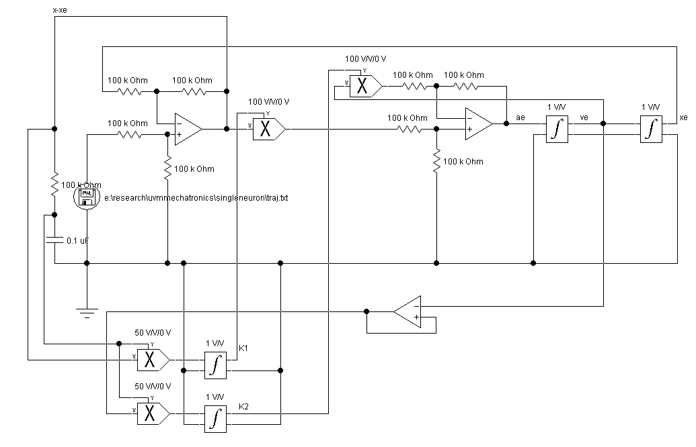
First Try- Self tuning one neuron neural net A/V estimator
6/22/01
Dr. Ned Lecky

